Our goal in this section is to figure out an expression for the kinetic energy.

# Figuring Out the Expression for Kinetic Energy

To achieve this objective, let’s begin our study of energy with, as usual the simplest possible situation. Consider a one-dimensional situation where a force is used to accelerate an object in a direction parallel to its initial velocity. Such a situation occurs for the package on the roller belt conveyor system shown in Figure 1.

*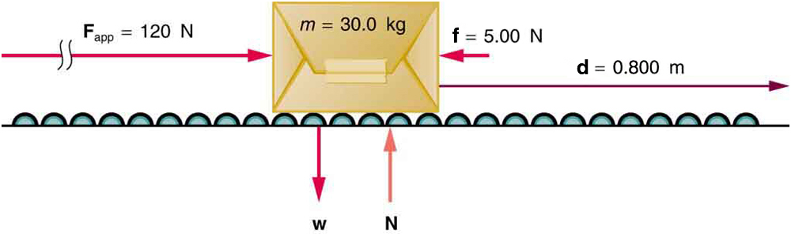A package on a roller belt is pushed horizontally through a distance d.*

In this case, there is no transfer of energy by molecular collisions, i.e. there is no heat and Q=0. Meaning that our statement of conservation of energy goes from

$$E=Q+W$$

to

$$E=W$$

Similarly, there is no ability to do work due to position; the box cannot fall because of the rollers. Thus, there is no potential energy in this problem and all of our energy is kinetic energy: E=K. Therefore, our statement of conservation of energy for this situation is just

$$∆K=W$$

$$K_{f}-K_{i}=W$$

The effect of the net force Fnet is to accelerate the package from *v*0 to *v*. The kinetic energy of the package increases, indicating that the net work done on the system is positive. (See [Example](https://cnx.org/contents/Ax2o07Ul@9.86:P_-6tVsN@5/Kinetic-Energy-and-the-Work-En#fs-id1703845).) By using Newton’s second law, and doing some algebra, we can reach an expression for kinetic energy.

The force of gravity and the normal force acting on the package are perpendicular to the displacement and do no work. Moreover, they are also equal in magnitude and opposite in direction so they cancel in calculating the net force. The net force arises solely from the horizontal applied force Fapp and the horizontal friction force f. Thus, as expected, the net force is parallel to the displacement, so that *θ*=0º and cos*θ*=1, and the net work is given by

*W*net=*F*net*d*.

Substituting *F*net=*ma* from Newton’s second law gives

$$Wnet=mad$$

To get a relationship between net work and the speed given to a system by the net force acting on it, we take

$d=x-x_{0}$

and use the equation studied in [Motion Equations for Constant Acceleration in One Dimension](https://cnx.org/contents/031da8d3-b525-429c-80cf-6c8ed997733a@9.86:ea2bb23c-4fce-4e9d-a46b-3754125da988@9) for the change in speed over a distance *d* if the acceleration has the constant value *a*; namely, *v*2=*v*02+2*ad* (note that *a* appears in the expression for the net work). Solving for acceleration gives *a*=(*v*2−*v02)*/2*d*. When *a* is substituted into the preceding expression for *W*net, we obtain

$$W_{net}=m(\frac{v^{2}-v_{0}^{2}}{2d})d$$

The *d* cancels, and we rearrange this to obtain

$$W_{net}=\frac{1}{2}mv^{2}-\frac{1}{2}mv_{0}^{2}$$

# Interpreting the Result: Kinetic Energy

*David: This section is taken from* [*http://umdberg.pbworks.com/w/page/68405433/Kinetic%20energy%20and%20the%20work-energy%20theorem%20(2013)*](http://umdberg.pbworks.com/w/page/68405433/Kinetic%20energy%20and%20the%20work-energy%20theorem%20(2013)) *with a few edits*

What has come out after all our manipulations is a that the work in this case is related to a change in a quantity associated with motion, 1/2*mv*2.  This is kind of like momentum in that it counts both the mass and the velocity, but it differs in that momentum is proportional to the velocity vector -- so it is very directional. Reversing momentum is a big deal even if the speed doesn't change. For our new quantity, since it is proportional to *v*2 instead of to *v*, the direction of motion doesn't matter. You get the same *v*2 whether *v* is positive or negative. If our general result turns out to only depend on the magnitude of *v* and not the direction (it will), we will have solved our problem and learned what it is that changes an object's speed (not caring about direction).

When you compare the result of our manipulations to our analysis in terms of energy, you can see that 1/2*mv*2 must be the *kinetic energy*.  It is a measure of "the energy associated with how much an object is moving".